Report based on the questionnaire: “Student Beliefs on Learning”
It seems that 64% of the students they are in a classroom so as to learn. The teacher is a resource for learning. Only 36% seems to feel everyone’s eyes on them and that the teacher’s face is evaluating them. 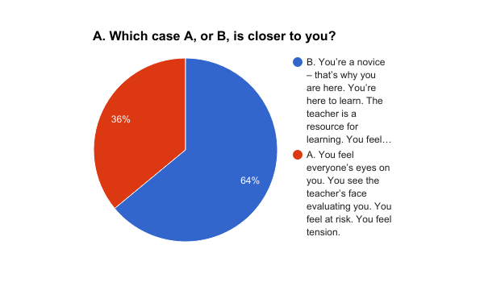

B1. About 80% of the students either agree or strongly agree that all people can be successful (50% agree and 30.8% strongly agree)
B2. About 60% of the students either agree or strongly agree that peoples’ intelligence is something about them that parents or teachers can greatly change through learning. 24% feel uncertain whereas only 16% disagrees with this belief.
B3. About 50% agrees or strongly agrees that people can learn new things but they can’t really change their basic intelligence. 34% disagrees with this belief and 15.4% is uncertain. It seems that they are divided.
B4. The vast majority (about 84%) disagrees or strongly disagrees with the belief that struggling students have very low chances of success.
B5. The vast majority (about 90%) disagrees or strongly disagrees with the belief that people have a certain amount of intelligence and they really can’t do much to change it.
C.
The majority enjoys learning because they are interested in intercultural communication and they want to be able to communicate with others in English, or because they enjoy leaning English

80.8% | I enjoy learning because I am interested in intercultural communication and I want to be able to communicate with others in English, or because they enjoy leaning English

As far as feedback is concerned, they seem to prefer to receive feedback in the following order:
76.9% | I enjoy receiving feedback which comments on the effort made on mastering a new challenge and/or the strategies I used
73.1% | I enjoy receiving feedback on a personal basis and not in front of my classmates
57.7% | I enjoy receiving feedback which praises my ability and performance, e.g. ‘Hey, you’re a great writer’, or ‘How talented you are’, or ‘Hey, great job, you’re really smart’
57.7% | I enjoy receiving feedback which provides something that I may not want to hear, something that will help me explore my edges and potential
All in all, they prefer to receive feedback on the effort made and on a personal basis. Only 6 students, that is 23.1%, don’t mind receiving feedback on their learning performance in front of their classmates
23.1% | I don’t mind receiving feedback on my learning performance in front of my classmates

The majority seems to enjoy demonstrating their skills and abilities.
65.4% | I enjoy demonstrating my skills and ability

They seem to be divided as far as the feeling of accomplishment caused by challenging tasks and the anxiety caused by unfamiliar territories.
42.3% | I enjoy accomplishing something challenging that involves me in displaying ignorance and risking periods of confusion and errors
42.3% | I worry about setting goals that will put me into unfamiliar territory risking the danger for me to look ‘stupid’.

Only 4 students seem to enjoy learning more quickly and better than their classmates.
15.4% | I enjoy learning more quickly and better than my classmates

DISCUSSION ON THE FINDINGS
The results show that you cannot categorize the students into struggling or advanced. The answers to the first question seem to depend on personality. Even advanced students seem to be in tension when called by the teacher to the front of the room and he/she starts throwing questions at them one after another.
The fact that the majority of the students feel that they are in a classroom/school to learn and that the teacher is a resource for learning may have to do with the fact that this is an experimental school and it is the students’/parents’ choice to attend this school, even through lottery. Students and parents have high expectations of the school and are highly motivated. All in all, I would say that they seem to ascribe to the growth mindset or closer to the growth mindset.

